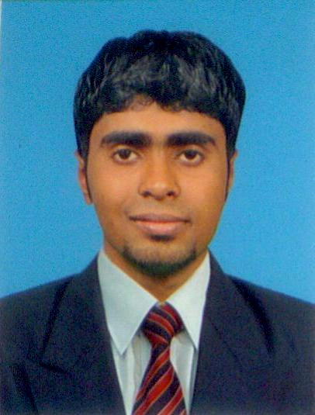 CURRICULAM VITAE

M.C.M. Hassan
No. 353, Kurunegala Road,
Nugawela.
Email: shakibulhassan60@yahoo.com
Tel: 094752051047, 0776541472, 0815680617

OBJECTIVE
To be an active and professional team player in a dynamic work environment, where my skills could be maximized to achieve a higher standard in my carrier.

VISION
Unleash the potential in an opportunity where I could.

MISSION
Give my entire commitments in order to achieve the targets entrusted upon me.

EDUCATIONAL QUALIFICATIONS
- Successfully completed a BTEC HND in Quantity surveyor at British College of Applied Studies. (BCAS CAMPUS)

Successfully completed the following areas
- Surveying & leveling
- Civil Engineering Materials
- Building Services
- Building Measurement
- Drawing Techniques
- Advance building measurement
- Tender estimate
- Civil engineering measurement

PROFESSIONAL QUALIFICATIONS

- Successfully completed an English Course.at College of British council.
- Successfully completed excavator operator course at Tech vision lanka.
- I have a good knowledge of English and Arabic languages
- Successfully completed Diploma in English.

ACADEMIC BACKGROUND
- School Attended – Azhar College National School Akurana Sri Lanka.

ACADEMIC QUALIFICATIONS
- Finished my General Certificate of Education (Ordinary Level) Examination on December 2006.
- Finished my General Certificate of Education (Advance level) Examination August 2009.

PROFESSIONAL EXPIRIENCE
- I worked Sales Representative at kamal cable (pvt) Ltd
- I worked customer service at Riyadh international catering corporation {McDonalds Saudi Arabia}
- Currently I’m working as a trainee quantity surveyor at S & A construction pvt Ltd.

OTHER ACTIVITIES
- Member of School Prefect Board.
- Member of the Sports Club.
- Member of the Commerce Unit.
- Member of Islamic Student Movement.
- Participated in the Athletic Event in Circuit meets.
- Member of the School Cricket team.

PERSONAL INFORMATION
Name in full: Mohamed Cassim Mohammed Hassan Marikkar.
Name with Initials: M. C. M Hassan Marikkar.
Address: No; 353, Kurunegala Road, Uyanwatta, Nugawela.
Gender: Male
Date of Birth: 11th September 1990
Marital Status: Single
Nationality: Sri Lankan
NIC No: 902550925V
Passport No: N2468555
SL Driving License: B767255
Weight: 52 Kg
Height: 5’7”

NON-RELATED REFEREES

Mr. M.L. Thayoob (D.I.M.S) MR.W.K.C Dissanayake (Teacher)
Doctor, No.42/a, Nikathanna,
No. 26, Daulagala Road, Katugasthota.
Handessa. Tel.0712564566 Tel. 077-6046032

I do hereby certify that the above mentioned particulars are true and correct to the best of my knowledge.

Date:11/11/1015 M.C.M. Hassan

